To: The Record
From: Don Bellenger
Subject: Initial Setup for git CF Code on Donport foro BBSG
Date: 07/26/2018

Miscellaneous notes:

How to delete a DON branch locally and remotely.
In the Don Working Directory, git bash here.
git checkout master
git branch –d don (this deletes the local)
git push origin :heads/don (this deletes the remote)
Here is how to create a new branch locally and remotely.
Create the branch locally and then push it to the remote repo:
git checkout -b new_branch_name
git push origin new_branch_name

One Time Setup for a Work Area on Donport4

In this example, we will set up a TEST work area based on the bbsgdv1 work area, and dev branch. The application name will be bbsgtest, and it will run on port 55088.

SET UP GIT
Easiest is to make a new branch – test- in the dev work area, using
git checkout -b test
git push origin test

Then using Windows Explorer, copy projects/cbsites/bbsgdv1 to projects/cbsites/dev/bbsgtest
In Windows explorer, cd cbsites
Right-click bbsgtest, tortoise git pull (this makes the remote test branch show up)
Right click bbsgtest, git bash here
Git branch –all (this shows remotes/origin/test, but NOT a local test)
Git checkout -t remotes/origin/test (this makes a local tracking branch for test)
Exit
You will see that Tortoise git shows “Commit test”, which is the new branch.
Use tortoise git to switch ot each of dev, test, and prod, and do a pull in each one, just to be sure everything is in sync.
Switch back to test.

Then right click bbsgprod, make sure it is showing “commit prod”, and do a pull (this makes the remote test branch show up.)
Repeat the git bash, setting up the git checkout -t remotes/origin/test and all the pulls. Leave bbsgprod connected to the prod branch.

Then right click bbsgdv1, make sure it is showing “commit dev”, and do a pull (this makes the remote test branch show up.)
Repeat the git bash, setting up the git checkout -t remotes/origin/test and all the pulls. Leave bbsgdv1 connected to the dev branch.

Now, in the TEST branch, which is the new one.
Cd bbsgtest

SET UP SUBLIME
BE CAREFUL, IT IS EASY TO MAKE A MISTAKE.
You need a project in sublime for bbsgtest
Start sublime
CLOSE whatever project was open.
Project, add a folder to project, and browse to bbsgtest.
Project, save project as bbsgtest.(sublime-project). MAKE SURE you are saving it in cbsites\bbsgtest

SET UP server-specific files in the workspace bbsgtest

Doubleclick .gitignore in the left panel in Sublime. BE SURE IT IS COMING FROM cbsites\bbsgtest

See the instructions for the edit of the .gitignore file later in this document.

Edit config/Coldbox.cfc. Here are some lines, with the new lines highlighted.
environments = {
localbbsgdv1 = "^127.0.0.1:56801",
localbbsgtest = "^127.0.0.1:55088",
localbbsgprod = "^127.0.0.1:55072",
remotebbsgdev = "^dev.uisdesign.com",
remotebbsgtest = "^test.uisdesign.com",
remotebbsgprod = "^bbsg.uisdesign.com",
remotedontempdomain = "^dontempdomain",
localCF11dev = "^127.0.0.1:8500"

}; // environments

//Datasources. name is the DSN in Railo. Passwords are HERE
datasources = {
ltdv1 = {name="ltdv1", dbType="mysql", username="bbsgcf1", password=".Nogo123"}, // property in datasources
lttest = {name="lttest", dbType="mysql", username="bbsgcf1", password=".Nogo123"}, // property in datasources
ltprod = {name="ltprod", dbType="mysql", username="bbsgcf1", password=".Nogo123"}, // property in datasources
ltdv1h = {name="ltdv1h", dbType="mysql", username="bbsgcf1", password=".Nogo123"}, // property in datasources
lttest1h = {name="lttest1h", dbType="mysql", username="bbsgcf1", password=".Nogo123"}, // property in datasources
ltprodh = {name="ltprodh", dbType="mysql", username="bbsgcf1", password=".Nogo123"} // property in datasources
};

function localbbsgtest () {
// set custom title used in layout
settings.tabtitle = "LocTEST";
settings.cfEnv = "dev";
settings.cfEnvDesc = "Development";
// !!!THIS MUST BE CONSISTENT with "this.datasource" in application.cfc
settings.ltdsn = "lttest"; // this MUST be consistent the definition of DSN: lttest in the Railo Admin!!!!!!
settings.dbislocal = true;
settings.appserver = "lucee";

} // function localbbsgtest

Bring up server-bbsgdv1.json, and save as server-bbsgtest.json Then make the edits

{
"app":{
"cfengine":"lucee@5.2.3+35"
},
"name":"bbsgtest",
"web":{
"http":{
"port":"55088"
}
}
}

Bring up application.cfc, and edit

// !!! make this consistent with config/coldbox/settings and config/logbox !!!!!!!
this.datasource = "lttest";

Bring up config/LogBox.cfc and edit
function configure(){
logBox = {

// Define Appenders
appenders = {
MyAsyncFile = {
class = '/logbox.system.logging.appenders.FileAppender'

,properties = {
filePath='/logs'
} // properties

} //MyAsyncFile

// to-do: parameterize this
, MyDB = {
class = '/logbox.system.logging.appenders.DBAppender'
, name='LTWebDB'

, properties = {
dsn = "lttest" // THIS IS HARD-CODED. Maintain consistency with this.datasource !!!
,table = "log"
,autocreate=true

} // properties

} // MyDB

} // appenders

// Root Logger. Assign all appenders
,root = { appenders="MyDB" }
};
} // function configure

Bring up box.json and edit
{
"dependencies":{
"coldbox":"folder:C:\\Projects\\cbsites\\bbsgtest\\coldbox\\"
},
"installPaths":{
"coldbox":"coldbox/"
}
}

Bring up go.boxr
# bbsgtest\go.boxr

server start cfengine=lucee@5.2.3+35 port=55088 name=bbsgtest --force

TEST

Set up C:\Users\Don Bellenger\Documents\WindowsPowerShell\Microsoft.PowerShell_profile.ps1

#C:\users\Don Bellenger\Documents\WindowsPowerShell\Microsoft.PowerShell_profile.ps1
#go to PMSES
function go {cd "C:\projects\cbsites\CF2016"
box}
function gobbsg {cd "C:\projects\cbsites\bbsgdv1"
box}
function gobbsgtest {cd "C:\projects\cbsites\bbsgtest"
box}
function gobbsgprod {cd "C:\projects\cbsites\bbsgprod"
box}

Set up bookmark in browser for LOCAL bbsgtest fwreinit = 127.0.0.1:55088/index.cfm?fwreinit=nutbox

Open a ConEmu window, and type gobbsgtest. This will cd \cbsites\bbsgtest, and start box.

At the CommandBox prompt, enter
Recipe go.boxr

This will take a while, then fail, since the data sources have not been set up.

Here is a screenshot in Araxis Merge when you are done. (Coldbox.cfc would also be highlighted).
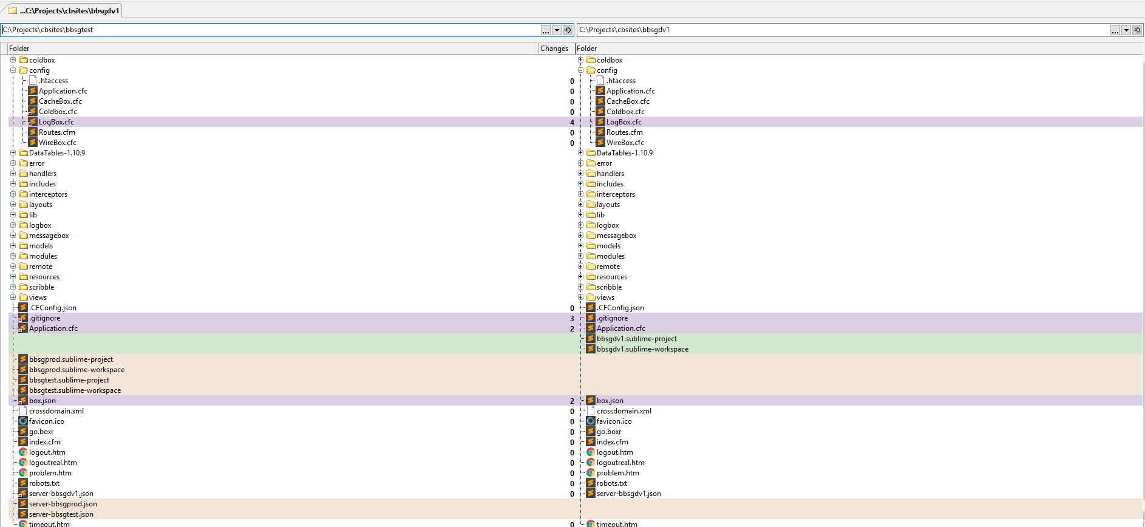
Edit the .gitignore file. Here is the listing from 7/26/2018, and the highlighted lines are what are added.

# .gitignore

# ignore these folders
.git/*
.settings/*
generated/*
resources/*
scribble/*
WEB-INF/*
CFIDE/*
jakarta/*
logs/*
modules/*
resources/*
messagebox/*
resources/*
storages/*

# ignore directories created by Araxis Merge
LOCAL.bbsgdv1/*
BASE.bbsgdv1/*
REMOTE.bbsgdv1/*
LOCAL.bbsgtest/*
BASE.bbsgtest/*
REMOTE.bbsgtest/*
LOCAL.bbsgprod/*
BASE.bbsgprod/*
REMOTE.bbsgprod/*

# files
# these configuration files contain dsn information that is environment-specifig
Application.cfc
config/LogBox.cfc
~*.*
.project
*.bak
*bak.*
*.zip
*.apf
*.log
*.dat
*.sig
*.boxr
robots.txt
settings.xml
includes/DataManipulationLibOrig.cfm
Thumbs.db
*.sublime*
server.json

#ignore data
tmpupload/*

# except
!tmpupload/readme.txt
# End of .gitignore

